
Instruction Manual

SpeedDeck – Vancouver 2010 Olympic Edition

What’s included?

- Instruction Manual
- 104 colored chips (4 colors. A set of 26 chips for each color).
- One deck of 52 playing cards.
- 20 wooden “foul” chips.
- 2 x 2 feet square SpeedDeck game board.

The game of SpeedDeck is played on a 2 x 2 squire board (Diagram 1). The board is placed between, at minimum, 2 to, at maximum, 4 players. Drawn on the board are 26 cards that function as placeholders to show players how to place cards on the board.
The colored chips, or coins, are disc-like objects that are one of four different colors, which is different from one SpeedDeck variant to another. A complete set of chips consists of 26 chips per color for a total of 104 chips.

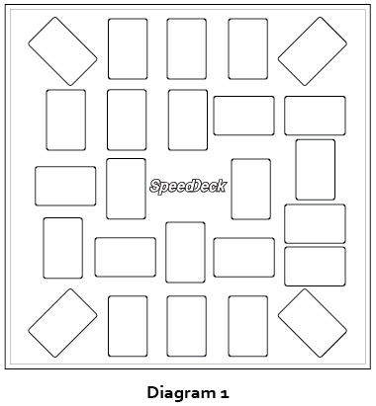

Rules For Game Setup

- 2 to 4 players.
- Rounds per number of players:
  - 2 players = 3 rounds
  - 3 players = 5 rounds
  - 4 players = 7 rounds
- Split the 52 playing cards into two shuffled groups:
  - Group 1 – Hearts & Clubs
  - Group 2 – Diamonds & Spades
- Randomly place all the cards from Group 1 cards on the card placeholders locate on the SpeedDeck game board.
- Place Group 2 on the center of the game board, faced down. This is the SpeedDeck draw pile.
- Each player chooses one color set of playing chips.

Rules of Play

- Players must start with their current chip in play under the table.
- No hovering over the SpeedDeck game board. Player’s hands must be in one of two positions 1) under the table or 2) placing their chip on a card.
- If a player put their chip on the wrong card they cannot play the next card (loosing one turn) and receives a foul chip worth negative five (-5) points.
- Each turn one card is removed from SpeedDeck draw pile and placed face up beside it.
- To win the card, players must find and be the first to place their current chip in play on the card with the same color and value located on the SpeedDeck game board.
- The winner places his current chip in play on the card he just won.
- When a card is flipped over from the SpeedDeck draw pile, and everyone rushes in to place their chip on the winning card for that turn, the player whose chip is the lowest (closest) to the game board wins the turn.
- If there is a tie between players they will enter into a tiebreaker round. A player not involved in the tie must flip one more card from the SpeedDeck draw pile. Only players who tied can compete in the playoff. Whoever wins this playoff gets both the playoff card points and the tiebreaker card points.
- Each round ends once all cards have been flipped from the SpeedDeck draw pile and players have captured all cards on the game board.
- Total each player’s score at the end of each round by adding up the value of each card, which they won, minus foul points.
- Repeat this process for all remaining rounds totaling a player’s score for all rounds to determine overall game winner(s).

Value of Cards

- 5 points per number cards
- 10 points per Jack, Queen & King
- 15 points per Ace

